*ISAD3000 Capstone Computing Project 1 Milestone 4 Group Report*

***Group E8: Amristar Industry Project [Virtual Jukebox]***

Group Members:

Austin Bevacqua, Bradley van der Zwan, Dillon Vincent,   
Ryan Webster, Tanaka Chitete

Table of Contents

***Capstone Milestone 4 Group Report*** ***2***

Study Contract **2**

Submitted Deliverables **3**

Agile Report **3**

Client/Supervisor Meetings 3

Group Meetings 4

Start/End of Sprint Meetings 4

Stand-up Meetings 4

Progress Tracking 5

Sprint 1 5

Sprint 2 5

Sprint 3 5

Sprint 4 11

Reflection 13

Group Toggl Summaries 13

# ***Capstone Milestone 4 Group Report***

*Group E8: Amristar Industry Project [Virtual Jukebox]*

# Study Contract

See below for the study contract the group has created, and the semester 1 assessment and deliverables sheet provided by Amristar – the industry partner.

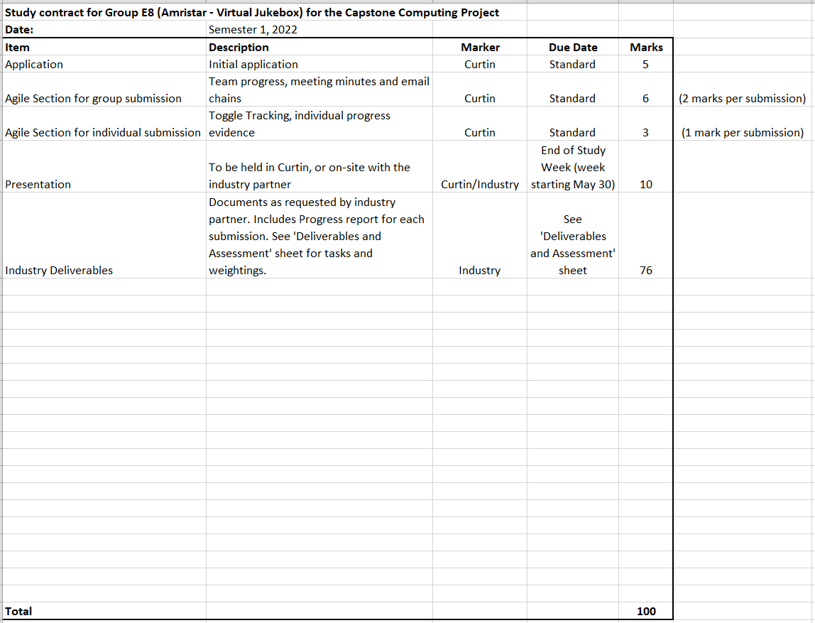

# Submitted Deliverables

The following link contains two submitted drafts of the Software Requirements Specification (SRS) deliverable for Amristar (v0.1, v0.2), as well as the final submission (v1.0).

<https://drive.google.com/drive/folders/18p0U6w9yyfh61fs7rk_411_MaoRMnZaE?usp=sharing>

The following link contains the submitted Project Plan draft and the final version for Amristar.

<https://drive.google.com/drive/folders/17VMDKc2MeCLrHJlokPBq67LVzy6Rfbfr?usp=sharing>

The following link contains the Progress Report and its submitted draft for the last reporting period, which was submitted to Amristar alongside the final TIS version.

<https://drive.google.com/drive/folders/17VlgypQ8n4dG-B56gFlGVpeyw84zuI4s?usp=sharing>

(See previous group milestone reports for older submitted deliverables)

# Agile Report

(Spans 15/04/2022 to 6/05/2022)

## Client/Supervisor Meetings

Both the client and the supervisor is Amristar. From 15/04/2022 to now (6/05/2022), the group has had three meetings with Amristar. The co-supervisor (or Curtin supervisor) is Senjian An.

In this reporting period, the three supervisor meetings were held on 19/04/2020, 26/04/2022, and 2/05/2022. No meetings were held with the Curtin supervisor.  
  
See below for a link to the group folder storing the meeting minutes taken at each of these meetings.

Supervisor meeting minutes’ link:

<https://drive.google.com/drive/folders/1rKsgHWpck5Wpd935lpXTCyADSaPFoQgS?usp=sharing>

Several email chains were developed in communication with the supervisor(s) to arrange these meetings and to send them the minutes after they ended. See below for a link to the group folder containing these email chains, as well as emails of group-meeting minutes sent to the co-supervisor, and other important emails sent to and from supervisors.

Supervisor email chains link: <https://drive.google.com/drive/folders/119b5OFNJMfTy7bHOhZ9OSrMT9BZEr8vT?usp=sharing>

## Group Meetings

Group meeting minutes link: <https://drive.google.com/drive/folders/1OImhOwUw_PIgKJ7r6JA-oma24w2zfaJa?usp=sharing>

### Start/End of Sprint Meetings

From the time-frame of the last reporting period to now, there has been a total of one sprint planning meeting (for sprint 4), and one sprint retrospective meeting (for sprint 3) held amongst the team.

Sprint 4’s planning meeting was held online on 3/05/2022. During this meeting, plans for activities to be undertaken for the respective sprints were discussed, with the team’s JIRA page being updated accordingly.

Sprint 3’s retrospective meeting was held online on 3/05/2022. This meeting consisted of creating action items based on what could be improved upon that sprint, as well as considering which aspects went well. See the minutes of these meetings for reflections on those sprints recorded during those meetings.

### Stand-up Meetings

There have been a total of four stand-up meetings during this reporting period, each of which involved discussions of individual member progress and issues.

These standups were held on 15/04/2022, 18/04/2022, 28/04/2022, and 30/04/2022. As the SRS deliverable required more collaborative work than the previous sprints, stand-ups were more focused on collaborative work than discussions on progress (as most progress was shared). This meant the stand-ups went for long time periods and were more productive than informative. For example, the first standup was held as soon as the sprint began, and resulted in brainstorming as a group before starting the SRS.

## Progress Tracking

### Sprint 1

FInished (See previous group report)

### Sprint 2

FInished (See previous group report)

### Sprint 3

Sprint 3 has finished (1/05/2022), and involved the completion and submission of two SRS drafts, which were used to gather feedback from Amristar to fine-tune the final submission, which was also undergone. Additionally, a project plan was completed in Microsoft Project, and submitted as a draft, before refinement and resubmission as a final version. A progress report was also completed (via a provided template) alongside a draft which outlined the team’s contributions and issues to the deliverable

The following sprint report outlines all tasks completed, and not completed during sprint 3.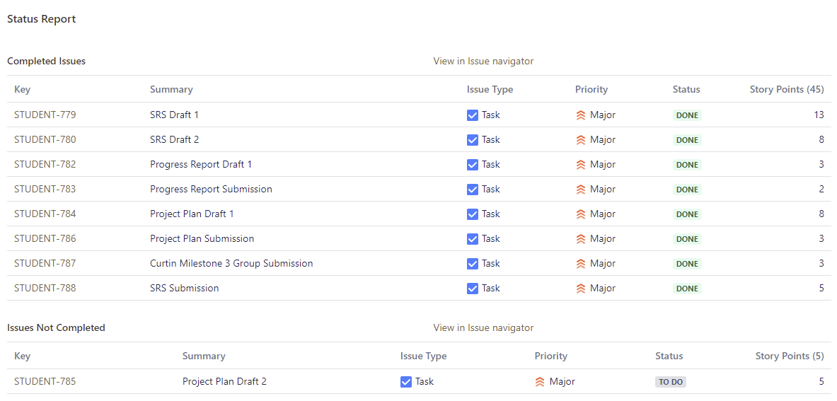

Most of the tasks for the SRS were not assigned to individual members as they required collaborative work (e.g. every member must agree on a requirement before it was added to the document). The Project Plan Draft 2 was not completed due to time constraints, but was not necessary for a successful sprint.

The following burnup and burndown chart showcase the sprint’s completed work in comparison to its scope:

**Burnup Chart**

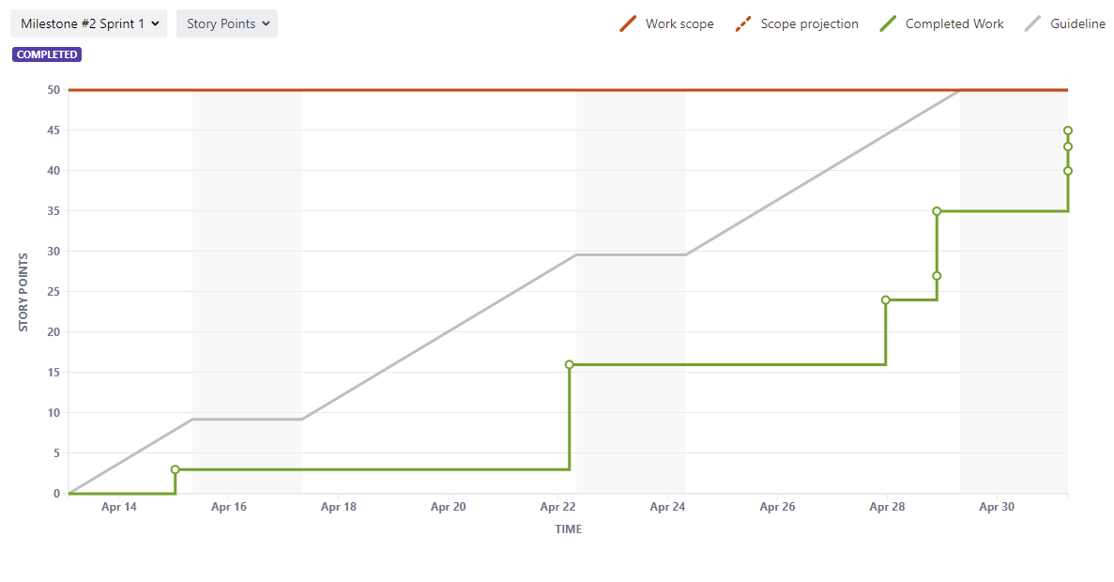

**Burndown Chart**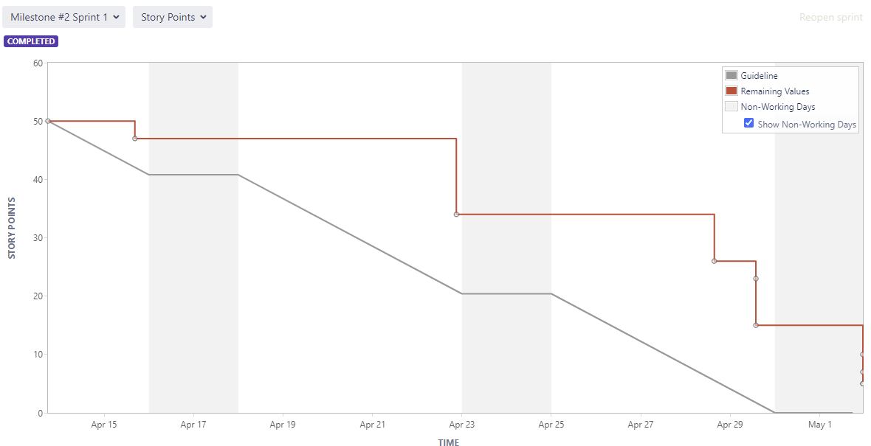

The team collaboratively brainstormed functional requirements using FigJam before the SRS was created. This brainstorming led to a variety of questions to be asked to the client (Amristar) which was done during a meeting. The following is the result of the brainstorming: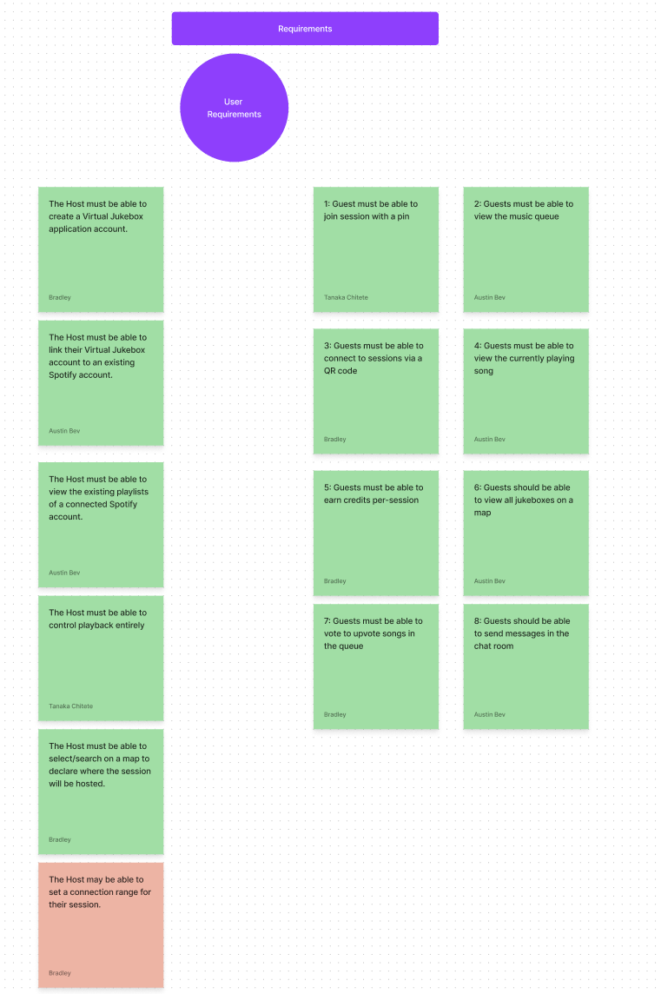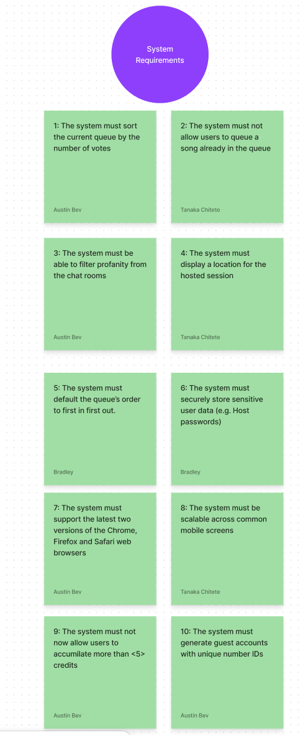

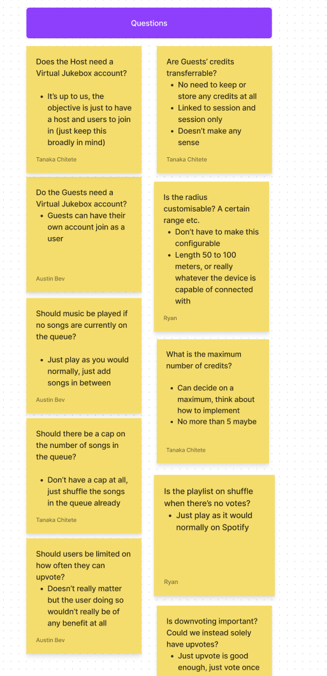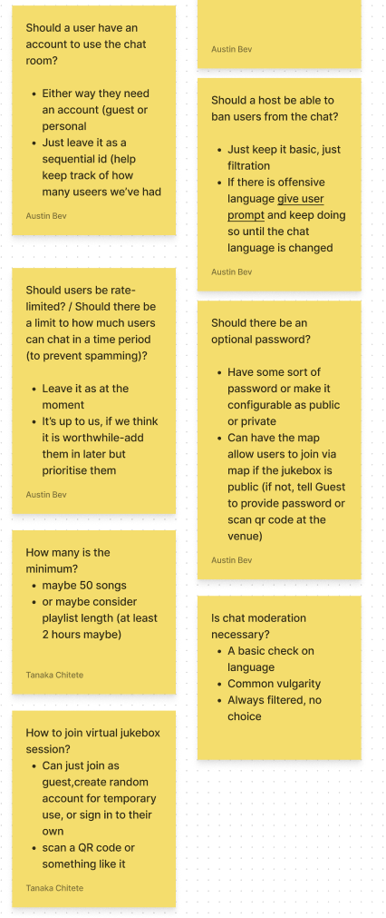

The following list outlines the achievements per person in sprint 3, as well as any other responsibilities they possess (see individual submissions for more detail and time spent):

* *Austin Bevacqua:*
  + As scrum master, was in charge of ensuring the group was following the agile process. Made sure the group was keeping Jira up to date, and every member was sticking to their assigned tickets.
  + Added all tickets to Jira with names, and allocated people their tickets.
  + Organised and ran sprint kickoff, retrospective and standup meetings.
  + Kept Jira up to date with current group progress
  + Helped brainstorm functional and non-functional requirements
  + Wrote initial functional requirements and added them to the SRS
  + Updated functional and nonfunctional requirements based on feedback. Added colour scheme and defined criteria
  + Updated formatting and structure of the SRS based on feedback
  + 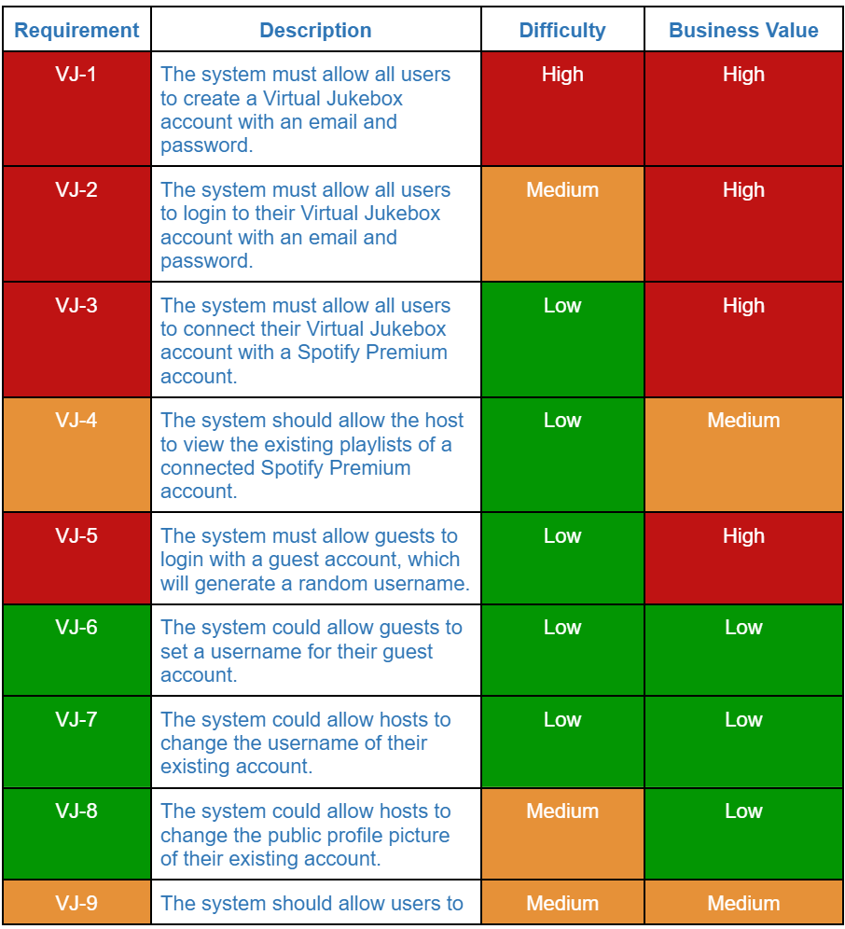
  + Contributed to the Project plan by providing estimates on tasks, and assigning tasks to people in the group.
  + Added personal contributions, contributions for next reporting period, and cumulative time-spent as a team to the progress report.
* *Bradley van der Zwan:* 
  + Added personal contributions, contributions for next reporting period, and cumulative time-spent as a team to the progress report.
  + Responsible for all meeting minutes, emails, and email compilations into the shared drive, and submissions of SRS drafts 1 and 2 and final. Also submitted drafts for the progress report and project plan
  + Additionally responsible for putting together the milestone 4 group report and its submission.
  + Created the first draft of the project plan.
  + Split and added all tasks and their dependencies to the final version of the project plan. Also helped add effort estimates and task assignments.
  + Helped brainstorm functional and non-functional requirements
  + Included the key actors, product perspective, assumptions and dependencies, and external interface requirements to the SRS.
  + Helped append to and reword functional and non-functional requirements.
  + Project Plan Draft 1: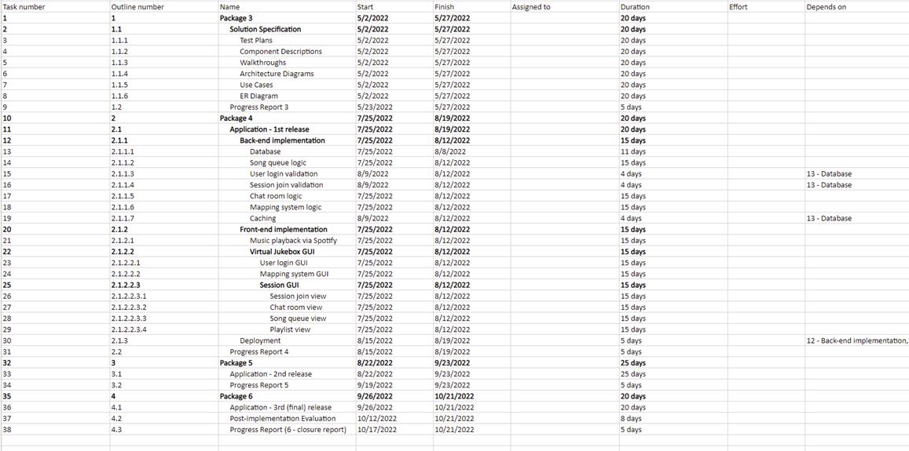
  + (See deliverable link for final project plan)
  + SRS Draft 1 contributions (See deliverable link for final version):

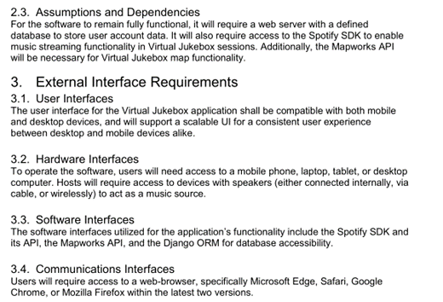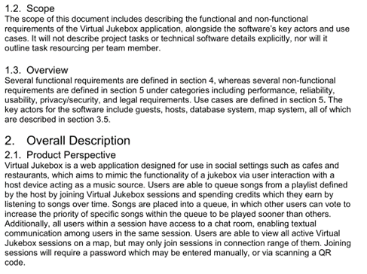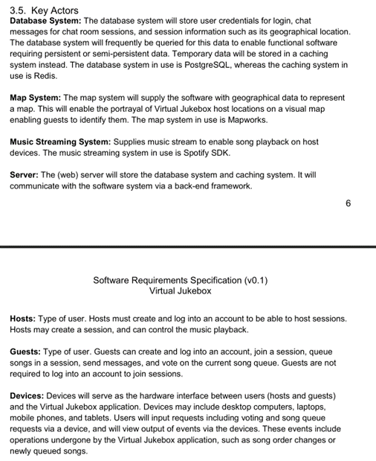

* *Dillon Vincent:*
  + Brainstorming of the functional and non-functional requirements
  + Looked at section 2.2 Product Functions
  + Proofread the SRS document
  + Helped with formatting the progress report for submission
* *Ryan Webster:*
  + Brainstorming and writing of functional and nonfunctional requirements.
  + Investigated existing solutions to further understand the requirements.
  + Estimated values for nonfunctional requirements.
  + Proofread and made adjustments to the final SRS document.
* *Tanaka Chitete:*
  + Devised outline for the contents of the SRS. The main sections include, “Introduction”, “Overall Description”, “External Interface Requirements”, “Functional Requirements” and “Non-Functional Requirements”
  + Also outlined the applicable sub-sections for each of the aforementioned sections
  + Actively took part in brainstorming Functional and Non-Functional Requirements for the application
  + Formally defined said requirements and made the necessary refinements for later publishing in final SRS document
  + SRS Draft 1 contributions (See deliverable link for final version):  
    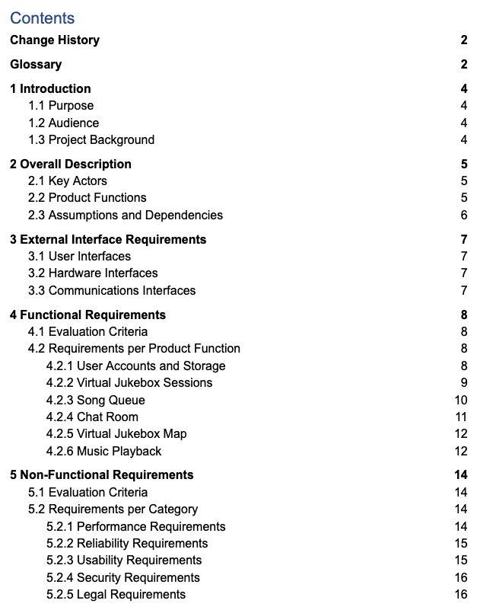

Before the final SRS submission, the team went through each functional and non-functional requirement and changed them/added to them based on feedback from the past two draft submissions. Formatting and grammatical mistakes were also fixed. Amristar had provided detailed feedback on each draft submission, which enabled a more refined final submission.

### Sprint 4

Sprint 4 has recently begun (2/05/2022), and will be one of two sprints up until the final submission of the solution specification deliverable. It will involve the submission of one document to Aristar, including:

* Solution Specification Draft 1, includes outlining:
  + Business Requirements and Goals
  + Business Model
  + Solution Architecture Model
  + Detailed Physical Architecture
  + Solution Impact
  + Quality Attributes
  + Success Criteria and Test Plan
  + Phasing, Roadmap, and Implementation Plan

The backlog at this current time for the sprint (as shown in JIRA {Based off of the Project Plan deliverable}- includes member assignment and effort estimates) is:

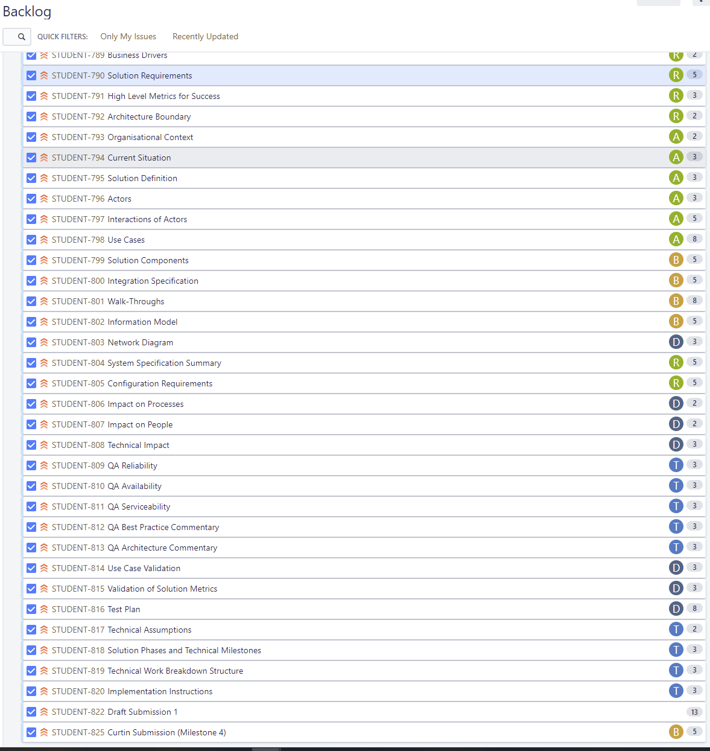

As sprint 4 has only recently begun (2/05/2022), not much has been achieved as of yet, however, JIRA tasks were assigned regarding the Solution Specification deliverable (based off of the provided template by Amristar) draft 1. Specific allocation of tasks per member have also been assigned in JIRA based off of the project plan defined in sprint 3.

## Reflection

Each group member has been present in every major meeting so far, with only a few absent in a couple stand-up meetings. No major issues have been present throughout each sprint so far except for time constraints. Sprint 3 was less smooth than the previous sprints as tasks required more collaborative work which was an issue for work consistency as it was difficult to find common times among each team member. Overall, sprint 3 was successful as the final SRS, project plan, and progress report deliverable was submitted on time (as well as two separate drafts of the SRS, and a progress report and project plan draft), however, some improvements could be made. Individual task allocation would have streamlined the deliverables by indicating to people their responsibilities. The third deliverable (Solution Specification) is currently on-track for completion by the given due date (29/05/2022).

## Group Toggl Summaries

Below showcases individual group member’s time spent as per Toggl throughout the reporting period. See individual report submissions for time break-downs per task.

**Austin Bevacqua**

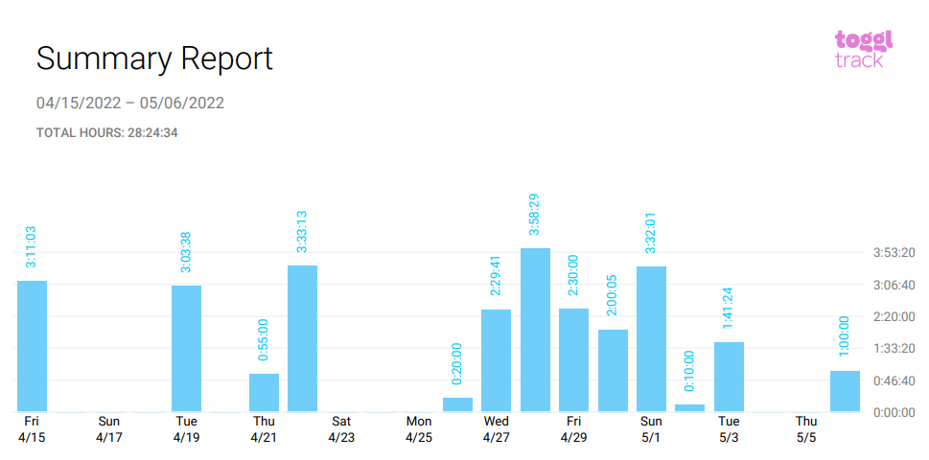

**Bradley van der Zwan**

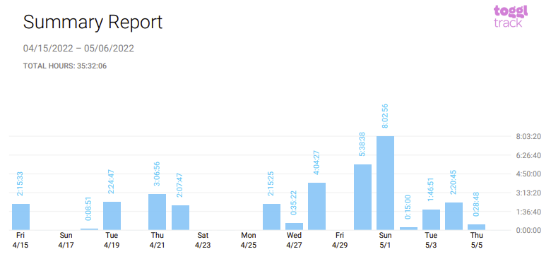

**Dillon Vincent**

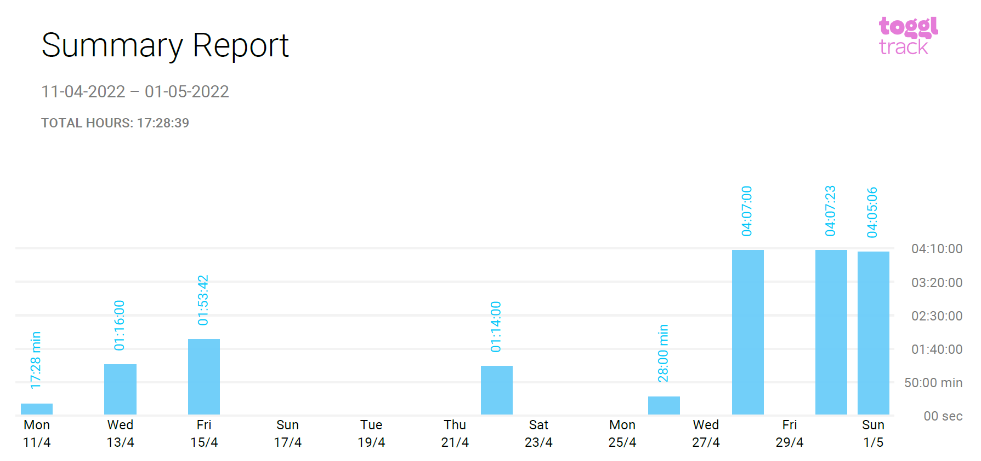

**Ryan Webster**

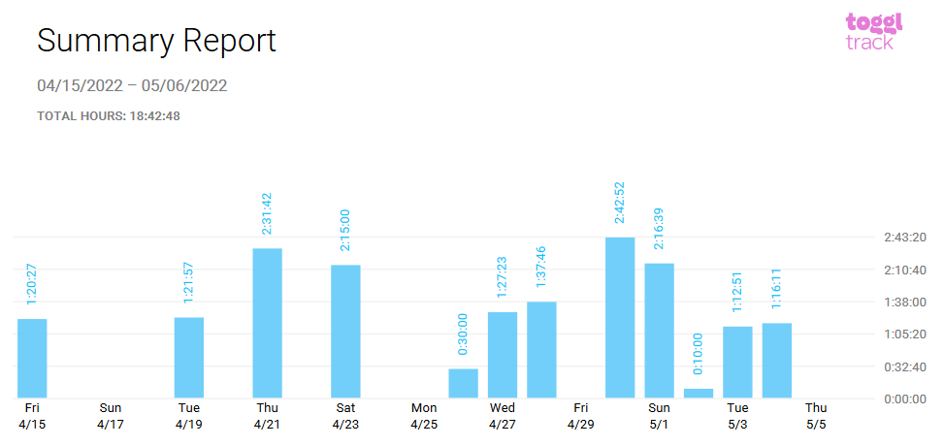

**Tanaka Chitete**

